# **How to eks cluster**

**Eks cluster**

* Create a Linux server with ubuntu os for setting up eks cluster

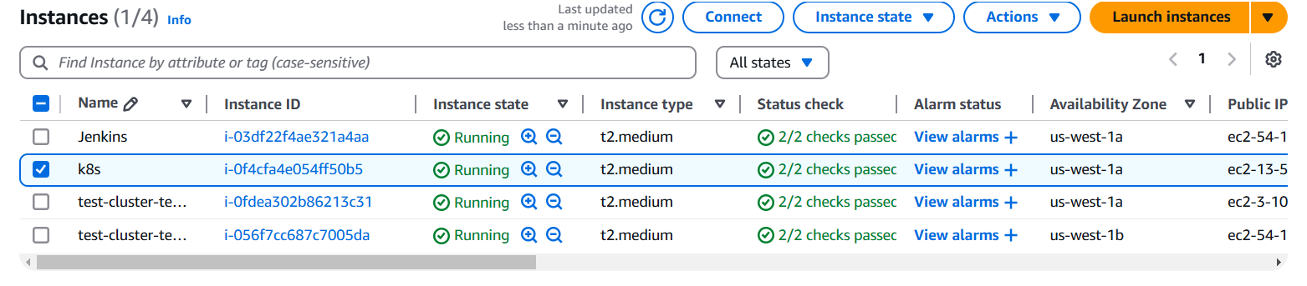

* Connect your ec2 instance with putty or mobaxterm using shh client
* After that you have to install following cli tools

1. **Eksctl**

**Description: -** eksctl is a simple CLI tool for creating and managing clusters on EKS - Amazon's managed Kubernetes service for EC2. It is written in Go, uses CloudFormation

**Command:**  # for ARM systems, set ARCH to: `arm64`, `armv6` or `armv7`

ARCH=amd64

PLATFORM=$(uname -s)_$ARCH

curl -sLO "https://github.com/eksctl-io/eksctl/releases/latest/download/eksctl_$PLATFORM.tar.gz"

# (Optional) Verify checksum

curl -sL "https://github.com/eksctl-io/eksctl/releases/latest/download/eksctl_checksums.txt" | grep $PLATFORM | sha256sum --check

tar -xzf eksctl_$PLATFORM.tar.gz -C /tmp && rm eksctl_$PLATFORM.tar.gz

sudo mv /tmp/eksctl /usr/local/bin

1. **Kubectl**

**Description: -** kubectl is the command-line tool for interacting with Kubernetes clusters. It allows users to manage Kubernetes resources and perform various tasks such as deploying applications, inspecting and modifying cluster resources, and troubleshooting cluster issues.

**Command: -**

* Install kubectl binary with curl on Linux

curl -LO [https://dl.k8s.io/release/**$(**curl -L -s https://dl.k8s.io/release/stable.txt**)**/bin/linux/amd64/kubectl](https://dl.k8s.io/release/$(curl%20-L%20-s%20https://dl.k8s.io/release/stable.txt)/bin/linux/amd64/kubectl)

* Validate the binary (optional)

Download the kubectl checksum file:

curl -LO [https://dl.k8s.io/release/**$(**curl -L -s https://dl.k8s.io/release/stable.txt**)**/bin/linux/amd64/kubectl.sha256](https://dl.k8s.io/release/$(curl%20-L%20-s%20https://dl.k8s.io/release/stable.txt)/bin/linux/amd64/kubectl.sha256)

* Validate the kubectl binary against the checksum file:

echo "**$(**cat kubectl.sha256**)** kubectl" | sha256sum –check

* Install kubectl

sudo install -o root -g root -m 0755 kubectl /usr/local/bin/kubectl

* Test to ensure the version you installed is up-to-date:

kubectl version --client

* If kubectl version is not visible execute following commands (its optional)

chmod +x kubectl

mkdir -p ~/.local/bin

mv ./kubectl ~/.local/bin/kubectl

kubectl version --client

1. **AWS CLI**

**Description: -** The **AWS Command Line Interface (CLI)** is a tool provided by Amazon Web Services that enables users to interact with AWS services from a terminal or command prompt. It allows you to perform various AWS tasks directly from the command line, including managing resources, configuring settings, and automating workflows.

**Command: -**

apt install unzip -y

curl "https://awscli.amazonaws.com/awscli-exe-linux-x86_64.zip" -o "awscliv2.zip"

unzip awscliv2.zip

sudo ./aws/install

**Confirm the installation with the following command: -**

**aws --version**

1. **AWS access key and secret key** you have to provide before that you have to create one IAM user with administrator access permission then generate access key and secret key and you configure these keys on your terminal

aws configure (execute this command on your terminal)

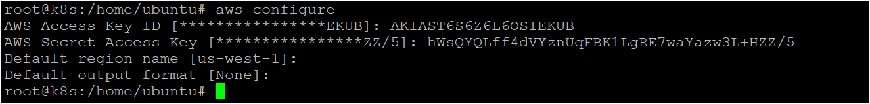

* Now you can create eks cluster by executing following command

eksctl create cluster --name <cluster_name> --region <your_region> --zones <availability_zones> --nodegroup-name <nodegroip_name> --node-type <instance_type> --nodes <no.of.nodes>

* Now your cluster is ready as shown below image 👇

